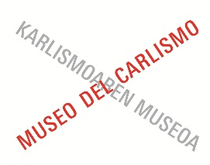
CALENDARIO DE VISITAS ACOMPAÑADAS GRATUITAS-2026
DOAKO BISITALDI LAGUNDUEN EGUTEGIA-2026

MES / HILABETEA | DÍA /EGUNA | 11:30 | 12:30 | 16:30 | 17:30

Enero / Urtarrila | 10 |  |  | Cast | Cast

Febrero / Otsaila | 7 |  |  | Cast | Cast

Marzo / Martxoa | 7 |  |  | Eusk | Cast
Marzo / Martxoa | 19 | Cast | Cast

 | 2 | Cast | Cast
 | 3 | Cast | Eusk
Abril / Apirila | 4 |  |  | Cast | Cast
 | 5 | Eusk | Cast
 | 6 | Cast | Cast

Mayo / Maiatza | 1 | Cast | Eusk
Mayo / Maiatza | 2 | Cast | Cast

Junio / Ekaina | 6 |  |  | Cast | Cast

Julio / Uztaila | 4 |  |  | Eusk | Cast

Agosto /Abuztua | 8 |  |  | Cast | Cast
Agosto /Abuztua | 15 | Cast | Eusk

Septiembre /Iraila | 5 |  |  | Cast | Cast

 | 3 |  |  | Cast | Cast
Octubre /Urria | 11 | Eusk | Cast
 | 12 | Cast | Cast

 | 1 | Cast | Eusk
Noviembre /Azaroa | 2 | Cast | Cast
 | 7 |  |  | Cast | Eusk

y | 1 | Cast | Cast
 | 3 | Cast | Eusk
Diciembre / Abendua | 5 |  |  | Cast | Cast
 | 6 | Cast | Cast
 | 8 | Eusk | Cast

- Eusk: euskera / euskaraz
- Cast: castellano / gaztelaniaz

